**Network Robustness:**

Robustness is the networks ability to maintain its connectivity when it loses some of its nodes or/ and edges due to attacks or faults in the system.

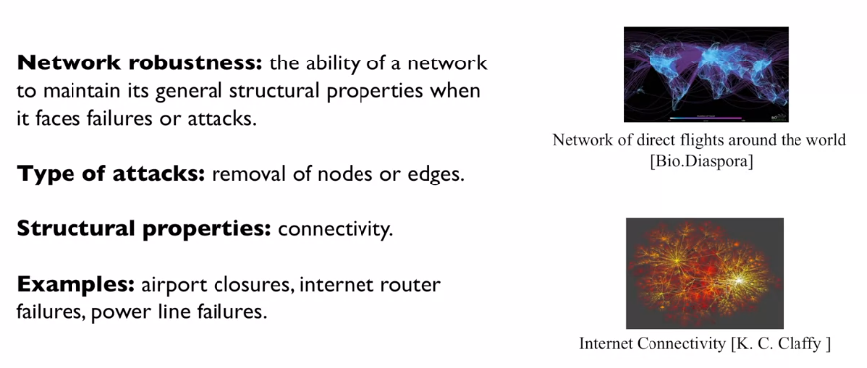

**Example**: airports, where the nodes are the airports and the edges are the flights. Sometimes airports need to close down, we would like for the transportation network to be robust and allow people to travel to other locations even if this airport is normally a stop.

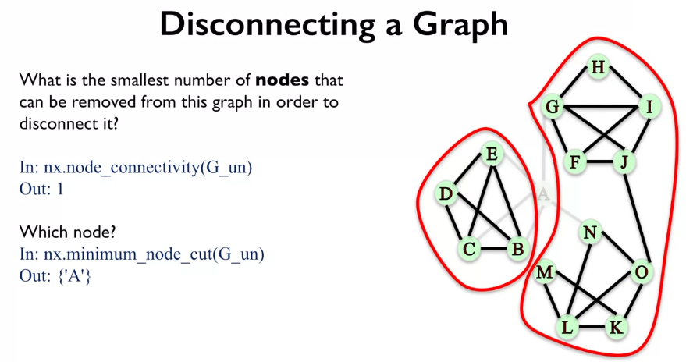

Going back to the airport example if A was an airport connecting America to Europe, this would be a disaster!

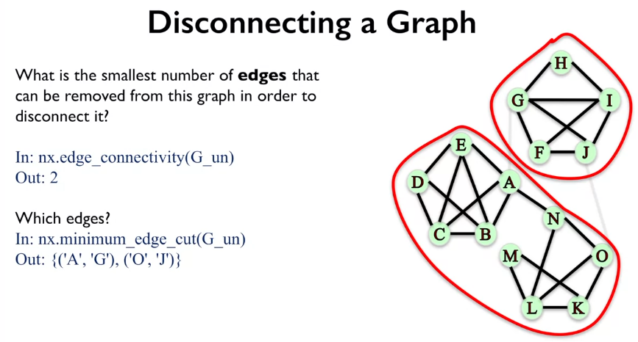

Of course, there are other edges that can do this e.g. A,G and A,N.

**Robustness:** A network is robust if you could remove lots of nodes and edges and it would still be connected.

**Directed Graphs and Robustness:**

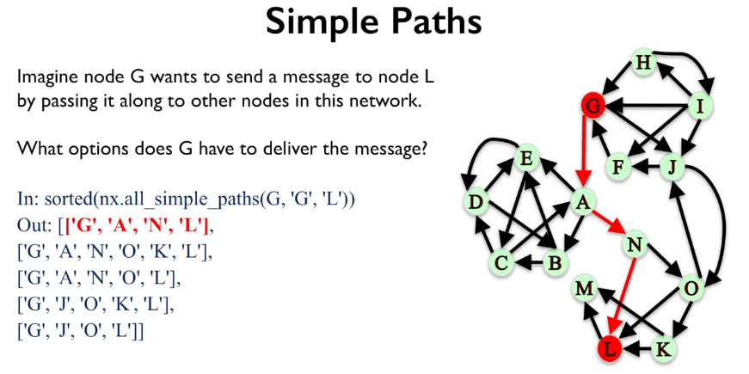

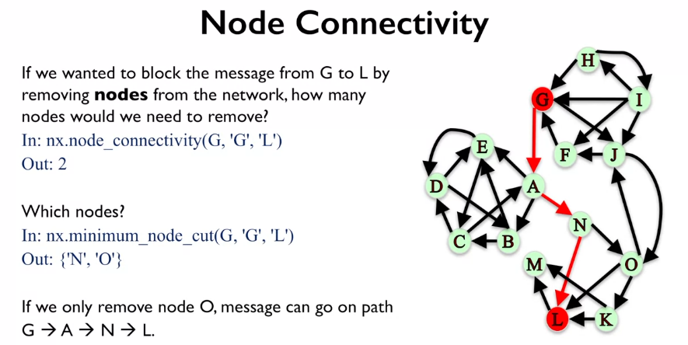

Again, the nodes returned from the minimum_node_cut() is the first ones found, but there could be more.

